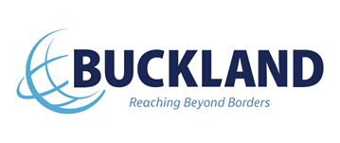
CTPAT Business Partner Agreement

Dear Business Partner,
In an effort to maintain a secure supply chain, Buckland Global Trade Services Inc. (Buckland) requires our business partners’ commitment to implementing the security requirements set forth in the Customs Trade Partnership Against Terrorism (C-TPAT) program.
Buckland supports our business partners in their supply chain security efforts and we are a certified and validated member of the C-TPAT program. Buckland’s Corporate C-TPAT Procedure requires that our supply chain business partners:
- Implement processes the meet or exceed the C-TPAT minimum supply requirements. These requirements may be viewed at the US Customs & Border Protection (CBP) website:
http://www.cbp.gov/border-security/ports-entry/cargo-security/c-tpat-customs-trade-partnership-against-terrorism
- Complete a written statement (reference the attached “YNA C-TPAT Business Partner Survey”) to demonstrate compliance with C-TPAT security criteria or an equivalent WCO accredited security program administered by a foreign customs authority.
- Requires that an Authorized employee of your company complete and sign the attached “YNA C-TPAT Business Partner Survey” to confirm that as an YNA business partner, (1) your company has been notified by YNA of the C-TPAT Program requirements; (2) your company has reviewed and understands the C-TPAT minimum security requirements and (3) your company meets the C-TPAT program requirements and will review your company’s supply chain procedures and implement necessary improvements, as needed.
- Notify YNA in writing of any changes in your company’s C-TPAT status (e.g., acceptance into the program or removal from the program), including the date of the change with your notice.

Thank you for your partnership and your cooperation to ensure that our supply chains are safe and secure.
Please send the completed survey to csausgroup@buckland.com, cwillett @buckland.com.
Sincerely,

Carol Willett
Senior Manager
Buckland Global Trade Services Inc.

